
Digital Signal Encryption/Decryption System (DSAD)

Final report
Nick Bidwell, Coby Wissing, Lisa Futch, Matt Keplinger

Department of Computer Science and Information Technology
Armstrong State University

Date: 02 May, 2018
Table of Contents

1 Executive summary (1-2 pages; 5 points) 3
2 Project background (2-4 pages; 5 points) 3
2.1 Needs statement 3
2.2 Goal and objectives 3
2.3 Design constraints and feasibility 3
2.4 Literature and technical survey 3
2.5 Evaluation of alternative solutions 4
3 Final design (3-6 pages; 20 points) 4
3.1 System description 4
3.2 Complete module-wise specifications 4
3.3 Approach for design validation 4
4 Implementation notes (3-6 pages; 30 points) 4
5 Experimental results (3-7 pages; 20 points) 4
6 User’s Manuals (2-4 pages; 20 points) 4
7 Appendices 5

Executive summary:
The Digital Signal Encryption/Decryption System (henceforth known as DSEDS) was a requirement for a small group project in CSCI-2070, Spring 2018 semester to act as a capstone project displaying the comprehension of encryption algorithms as well as basic computer programming concepts. A practical need for such a system could offer a basis of encryption for multiple data formats, as the flexibility of such a system could allow for different input and output formats to be programmed for a simple custom cryptographic system in a small-scale organization that may not have the assets to allocate to larger-scale efforts. As previously mentioned, our need for such a system is to showcase our comprehension of taught subjects in the fields of Cryptography and Computer Sciences.
This project was specifically outlined in a basic project specification document issued by Dr. Rasheed. The DSEDS was intended to take a binary string (no less than 64 bits, no less than 4 separate strings), run it through the TEA (Tiny Encryption Algorithm) block and display an analog output. Individual specifications for the TEA encryption included the utilization of a shift register on the binary string after TEA encryption block. To further satisfy the specifications of the assignment, the DSEDS had to be programmed to offer the option of either ECB or CBC (Electronic Codebook or Cipher Block Chaining) methods for the encryption/decryption blocks. Team 2 determined that a GUI would best accommodate the project requirements while providing ease-of-use and a clean interface for the display of the output.
Team 2’s goal was to satisfy the requirements of the project specification sheet and display both group and individual comprehension of CSCI-2070 curriculum as described on the course syllabus. Our solution to the requirement was programmed in Java, on the NetBeans IDE. The intention of using Java was a base familiarity within Team 2, as well as an ease-of-use with the syntax for the team members with less familiarity. A GUI (Graphical User Interface) was authorized as an option for an additional 5 points, which Team 2 chose to pursue for both the point value, and the ease-of-use and simplicity a GUI would provide a user who has less familiarity with such a system.
Initial testing of the different blocks (encode and decode, TEA block, etc.) showed that while our group meetings offered a chance to coordinate our efforts, individual knowledge and comprehension of specific tasks provided a slight hindrance to the overall project progress. Specifically, utilizing the TEA algorithm as coded produced three extra bits outside the project specification of 64 bits, requiring additional coding to replicate the bits in the decode process and ensure the integrity of the initial message. Tweaking of the TEA block, along with the CBC and ECB modes, provided a solution to the problem without creating additional issues.
Aside from the TEA block, a design issue arose with the choice of the Java language as Java drops binary 0’s from the beginning of messages in the DSEDS, creating a shorter-than-specification message and affecting the overall integrity of the message. Upon realization of this, additional lines of code were added to provide padding (replacing the 0’s in the front of the message) as to not affect the circular shift function, and to retain the integrity of the message.
The more experienced members of the team (with the Java language) were able to provide direction and guidance, as well as technical consultation on the more complicated blocks of code to the less-experienced members of the team. The result was all members gaining a basic comprehension of Java, all members gaining knowledge of TEA, and all members moving through rotating positions, based upon individual expertise, to offer leadership and contribute to the project management process for DSEDS.

Our experiences with project management in a small-scale project as such were limited in responsibility, but widely varied in scope. Initially, team 2 had issues getting communications established with all group members, so commercial assets (mass-text messaging) were utilized to establish a communications baseline with the Armstrong University email system used as an alternate means of communication should the primary communications fail. Individual members acted as managers of various aspects of the project from overall organization, to implementation of program blocks and classes, to establishment of a user manual and development of the GUI.
To directly reference the PMBOK (Project Management Body of Knowledge, Sixth Edition, 2017) which outlines a body of knowledge that is generally recognized as “good practices” in the project management fields, each of the five process groups was utilized (sometimes on a very small-scale) throughout the development of the project.
- The Initialization phase of the project was initiated by Dr. Rasheed with the criteria of the project defined and groups assigned during Spring Break, 2018.
- The Planning phase was initiated in part by Dr. Rasheed, and in part by Team 2 with the initial meeting to discuss how each member would contribute to the project utilizing their own strengths and addressing individual and collective weaknesses to simplify assigning work and project tasks. Group members established communications and a shared storage asset (Google Drive) to allow project continuity in the event of absences or other life-events.
- The Execution phase was initiated by Team 2. Bidwell and Wissing each developed a UML and pseudo-code for various blocks, Futch developed a GUI, and Keplinger worked on the TEA block syntax to Java. The team collectively brainstormed methods for the ECB and CBC toggles, and ways to generate individual user profiles.
- The Monitoring and Controlling phase of the project was a collective “checks-and-balances” system in which each member of the group was accountable to the remaining entirety of the group for their work, or lack thereof. Continued absence of several group members led to the group decision to remove the ineffective members and divide the remaining workload amongst the members that were present.
As mentioned previously, issues arose with the integrity of the message due to issues either in the TEA block, or with the Java language dropping 0’s. The team collectively evaluated the various program blocks on 24APR18, and overall feedback was taken from all group members. A unanimous decision to use a Graphical User Interface(GUI) version was made earlier in the project, but to retain the ability to use a Command Line (Console)- format as well for increased flexibility. The console version does not offer the graph plot function but retains all other functionality. Individual group members have been used as Quality Control checks for various stages of the project based upon experience and comprehension of various aspects of the DSEDS project.
*It is critical to note that in this phase of the project, members that had yet to be contacted were dropped from the group. By this point, they could not offer significant contributions to the project as the work-load was developed under the continued assumption that they would not be present. This decision was made mutually within Team 2, and with Dr. Rasheed during team advisement meeting held 29MAR18.
- The Closing process deals with the final production of a product, and for our product, the demonstration will be held 26APR18. The report, and user manual will be turned in later. As this is the first version, many revisions would normally be released to tackle various user issues, but this is a final project and will not likely see further development with this team.

Project background:

The DSEDS project allows a potential user with a basic knowledge of Java to utilize the TEA encryption block with an array of data (binary for the project) and offer an encryption and conversion into another format (analog for the project) with the output represented graphically. Potential users for the DSEDS include low to medium-security encryption systems that would be suitable for electronic hobbyists, computer science students (for educational purposes) and for research into the suitability of encryption algorithms for various other purposes as defined by the scope of their individual research statements.
Essentially, the core of the DSEDS project is converting a binary (digital) signal to an analog signal. The main purposes of this conversion are often found in digital media devices that pull digital information from the internet for conversion to analog for playback. DSEDS utilizes the same approach, with the application of TEA, to offer a low level of security for uses potentially in communication between users that desire security, but do not need the higher levels of security as they are not targets for signal interception or electronic eavesdropping due to the nature of their communications. The base idea of the program is a system that could easily be expanded and modified to accommodate higher levels of security for more privileged communications, but for the purposes defined in the scope of the project, the TEA algorithm and utilization of a shift-register and user profiles will provide sufficient security for the intended users of the DSEDS.
Alternate uses of DSEDS-type systems (with or without end-user modifications) are prevalent in Audio/Video equipment, data acquisition systems, and Software-Defined Radio (SDR). DSEDS (as implemented in specifically-engineered hardware solutions) could be implemented as a retrofit to older equipment throughout various industries to allow compatibility with newer technologies. An ideal implementation of DSEDS would be as a bank of systems, multiplexed in communications, in an industrial/factory setting. Most older factory equipment requires control signals from multiple, programmable voltage sources, and a bank of DSEDS systems would not only fulfill that requirement, but the use of digital encoding would offer a level of accuracy that the previous generations of analog controls did not.
The use of individual DSEDS in digital potentiometers to replace the analog-type potentiometers on other types of equipment would increase accuracy of measurements required by the potentiometer, as well as improve efficiency and potentially reduce costs as the digital-type systems would be easily replaceable and serviceable by an end-user (who literally could swap the corrupted DSEDS module with a new one) as opposed to the previous generations of potentiometer that required calibration by a qualified electrician, costing an organization downtime and money that a DSEDS solution could save them.
The use of encryption with DSEDS in these applications is ideal in an industrial environment, as the ongoing threat of data capture and intellectual property theft, as well as the theft of specified procedures and processes used in the manufacture of specialty goods is prevalent in major industry. Any form of encryption on the DSEDS systems used to garble communications until they are received at the receiver would offer a base-level of security against most threat-actors seeking to capture specialized industrial data and processes for exploitation or re-sale to competitors. The use of encryption could also prevent interference with other types of machinery and receiver/transmitter systems in use to include security radios and surveillance systems.
A DSEDS system could be used in security equipment as well. Military-type radios often run a dedicated software board that receives various types of encryption “crypto fills” depending on mission. DSEDS could be used on a less-tactical scale for small-scale security operations and operations where signal interception is not going to cost lives, but transmitting an open signal is neither optimal for security purposes or for the threat of interference with other types of equipment or hardware in a facility.

Needs statement
The DSEDS project offers an open-source, easy to edit and implement solution to the technology shortcomings previously mentioned and address other needs that were outside of our Team’s original scope. Specifically, the DSEDS (for our purposes) displays a working knowledge and understanding of the Tiny Encryption Algorithm, Java Programming, basic Project Management principles, and the ability to utilize information learned in CSCI 2070 with the final product being DSEDS. Currently, there is minimal dissatisfaction with a current situation, as the current situation is our positions as students and the dissatisfaction would be explained as the Professor’s desire to measure our comprehension of the material taught during this semester. The simplicity of programming language in the DSEDS, paired with the use of Java as a platform-independent language, offer literally endless uses for DSEDS in its current configuration, as well as any end-user inspired variations to suit their specific needs.

Goal and objectives
The goal of the DSEDS project for Team 2, CSCI 2070, Spring 2018 semester was to display a functional knowledge and understanding of TEA, Computer Science and Computer Programming principles, and project management principles while working as a group to take a binary input, encrypt via TEA, encode, decode, decrypt via TEA, and display as an output on a graph plot in a GUI, not specifically in that order. The design is implemented to run via the platform-independent Java programming language and retain the simplicity and flexibility to allow customization for a variety of purposes. DSEDS is designed to be tailored to an end-user’s specific needs. Essentially, it is a skeletal system upon which the end-user (engineers) can add the muscle that will maximize the use of DSEDS in their specific applications throughout various industries.
The objectives of the project were to utilize TEA, work as a team to develop a project based upon a graded specification and display a knowledge of basic-to-advanced computer science skills necessary to complete the project. The initial objectives required a program to provide output, though based upon Team 2’s progress in the early stages, the option of a GUI was adapted, and soon after the option of the embedded graph to display the output was also adopted. Justification for the changes comes from the progress the team made in the project and the additional benefit of the GUI to end-users and the graph output could provide a diagnostic ability to an engineer (end-user) that is familiar with binary. The console version was developed in parallel with the GUI version for increased flexibility and additional options for end-users.
DSEDS is designed as a platform-independent, cross-industry solution. The specifications for the project were developed in CSCI 2070 by Dr. Rasheed, but the potential of the system in multiple industries allows for broad flexibility. Java was utilized as the programming language as it is usable on many operating systems found on systems across multiple industries.

Design constraints and feasibility
The DSEDS project showed specific complications and shortcomings when utilizing the Java language to work with binary data. The Java language was decided as it was deemed most suitable and team members had a wide spectrum of experience with it. A specific constraint would be the lack of experience in the Java language as displayed by several team members, but more experienced team members stepped up to assist and offer guidance to continue forward progress and to educate team members as to the syntax and application of various Java concepts. Another constraint was the restriction against using Java libraries, instead having to code each solution and not use the already-made solutions.

Evaluation of alternative solutions
Discuss the alternative designs that were considered throughout the project. Analyze the pros and cons of each of these designs and justify your decision to opt for a particular solution. You may have found additional alternatives aside from the ones in the proposal, so make sure you include all.
- Alternative solution 1: This was a choice between utilizing a console application or GUI. Team 2 chose to utilize a GUI for the primary project but offer the secondary option of the console as both a contingency and a flexibility option. As project specifications were stringent and graded, minimal investigation into alternative solutions was necessary or warranted. Project specifications clearly outlined the intended outcome for teams to accomplish. Due to the dual nature of this project, and the ability to use either interface, pros and cons are difficult to measure aside from the console version not providing a visual graph plot of the analog signal. This could be problematic in a final implementation for troubleshooting purposes (end-user), but if both were packaged together, a console version could be used at satellite locations and the GUI accessed should the graph be desired for troubleshooting.
- Alternative solution 2: This was a choice between programming languages. Java was chosen due to platform-independence and knowledge of Team 2. C# was considered as well, but final decision rested with Java based on unanimous team decision.

Final design

System description
The DSEDS project takes a raw .dat file from its home directory, runs it through an encrypt and encode process upon user choice of either CBC (Cipher Block Chaining) or ECB (Electronic Code Book) modes and outputs the results into two separate files, one encrypted file, and one encrypted and encoded file in the home directory. The outputs of the encrypt-encode process can be used as the input files for the decrypt-decode process. The benefit of this design is that a user could host those files on a network and pull them for upload for multiple scenarios requiring the same file types without the risk of user-input error. Applications for such a system include multiple banks of machinery (in an industrial setting) that all run the same processes. Another benefit would be configuring multiple transmitter-receiver sets for multiplexing utilizing the same source information, again with minimal risk for user error.
Upon initialization, the user chooses a profile (1-7), inputs the directories for the source file, key, and initialization vector (IV) file. The user then chooses whether CBC or ECB mode will be used, and the output is displayed in the console version and files generated in the home directory. The path for the file creation is hard-coded, but future revisions could include options to specify directory paths for generated files, and for files to pull data from.
For the decode-decrypt side of the system, the files generated from the encrypt-encode side are then chosen and uploaded. The output is displayed for our purposes, but for other applications could be then further input or converted to specific or proprietary machine language. The benefit of using a binary output is that it allows easy conversion into any proprietary language.
As for hardware specifications for such a system, minimal processing power would be required for the current variation, and the design offers the flexibility to be utilized on multiple platforms that are Windows, Linux, or Unix based. If proprietary hardware systems were required, such as industrial machinery, then the general syntax could be modified to suit the unique hardware by a competent programmer. For the project team, notebook computers utilizing Windows 10 provided a general hardware/software platform, with the IDE being either NetBeans 8.2 or Eclipse IDE.
The current version of the software requires the user to know the directories of the signal, key, and iv files. Future revisions could include a choose file dialog box, but for the specifications of this project, the directory choice does not need to be as flexible as an end-user version of the system. A screenshot has been displayed below to show the inputs as required for the ECB (Electronic Code Book) selection.

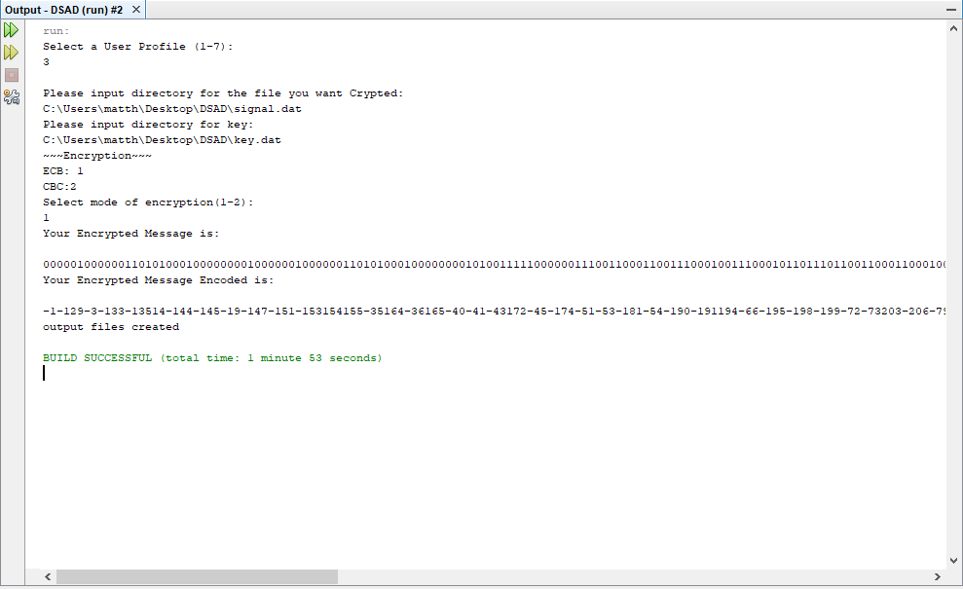
DSAD file inputs, ECB mode selection with output displayed and output files generated in directory. This is the encryption side inputs and “EncryptedFile.dat.” is output to the home directory.

Approach for design validation
The DSEDS project was tested by comparing outputs at various stages of the encrypt, encode, decrypt, and decode processes against the original source file. Various code changes were required as the outputs differed, and most changes involved switch-case statements for and to the output of the TEA block, and the TEA block structure as it was incompatible with the other blocks. Initially, the TEA block output the binary after the operations as a string, where the other blocks utilized an array format. Various files were generated and tested, and the DSEDS was tested on multiple systems to ensure it would function as designed.
All team members were downloading each other’s progress from a shared online storage asset, so cross-compatibility was rarely an issue, with the exception of using NetBeans vs. Eclipse IDE. The different IDE read the files differently and fixes that were implemented by team members to make the system run on their IDE sometimes proved to be a hindrance to team members using the other IDE.
Validation was also run with different source file sizes as the 256-byte file created a significantly different output due to the way the encrypt-encode block was coded.

Implementation notes

The overall flow of information from the input files, through the encrypt/encode block, to the output and decrypt/decode process is represented in its most simple form below.
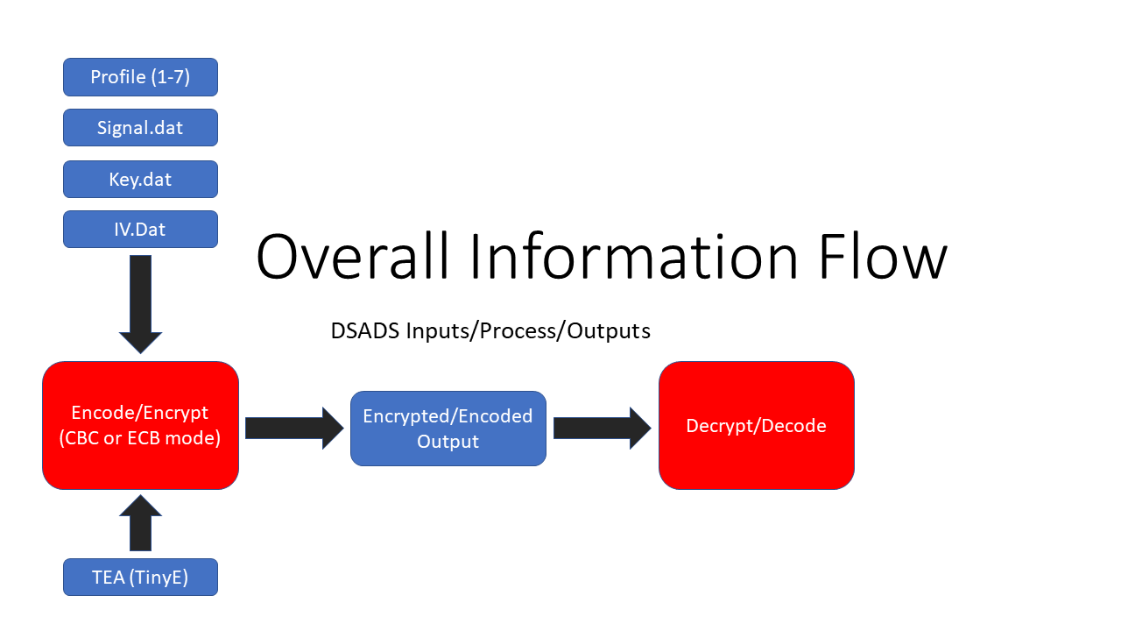
TinyE is the TEA encryption algorithm, while the inputs and profile choice are user input and the choice to use either CBC or ECB mode is chosen by the user. The output is displayed and transmitted into the decrypt/decode process to display the original values to the other end (receiver) of the system. An image of how the TEA algorithm works is shown below for clarity. The image represents two rounds of TEA in its original implementation.
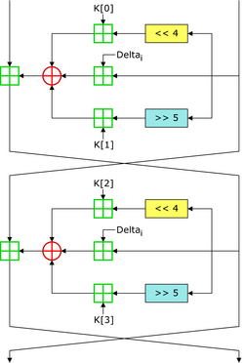
Source: https://upload.wikimedia.org/wikipedia/commons/a/a1/TEA_InfoBox_Diagram.png

Signal.dat represents the message to be encrypted and encoded and is represented as a basic.dat file for our purposes. The file is in the home directory of the DSAD system and is a necessary file for operation of the DSAD system.
IV.dat is the array values of the initialization vectors for use with the profile system. Upon choosing a profile, the appropriate IV is input as a value into the encryption block for use with TEA and the Signal.dat.
Key.dat is the array of key values in the home directory, also chosen with profiles. After the inputs are chosen (as displayed above) the user then chooses whether to use ECB or CBC with the TEA encryption. The output is displayed and can be fed into the decrypt/decode mechanism.

The encode process is displayed below, in Java, for reproduction/modification/customization. Encode class is fairly straightforward.
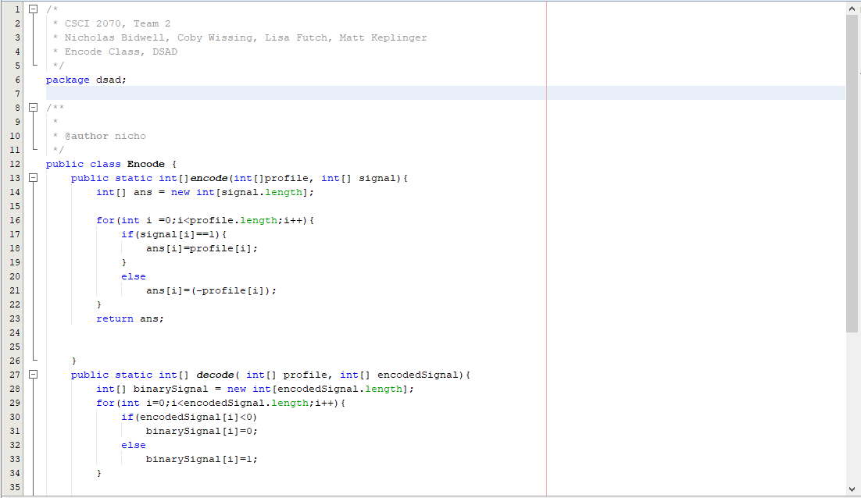
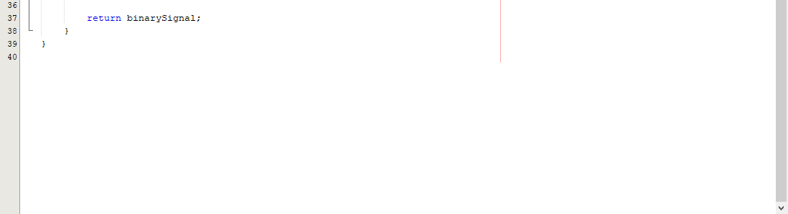

TinyE (TEA method) is displayed below to allow end-user an insight into the encryption method, our inputs, and output generation. Also, TEA could be replaced with other, more preferred encryption methods if necessary based on programmer experience level.
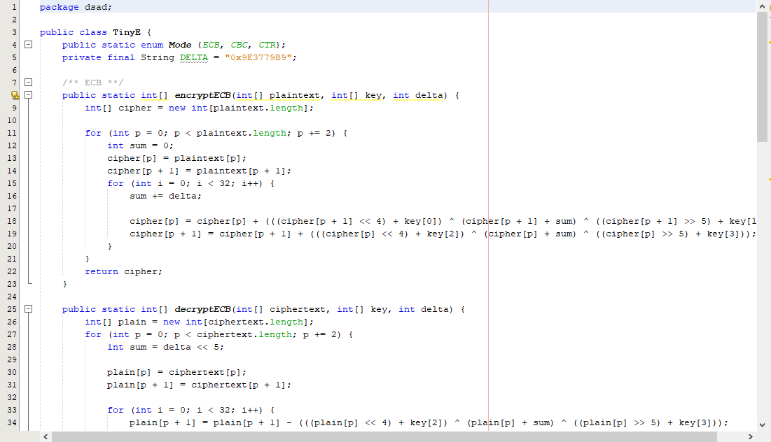
It is critical to note the line numbers on the left side of the images to re-assemble/comprehend the TinyE method.
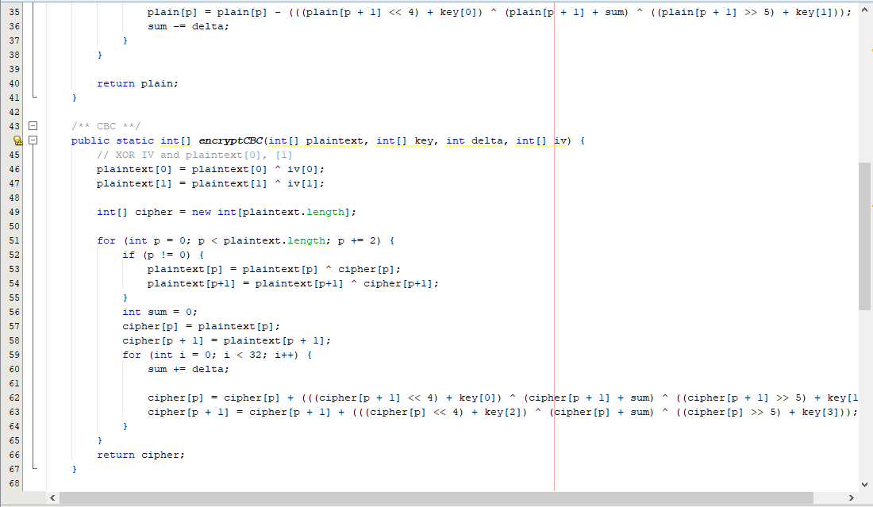

The decrypt method is displayed below and is part of the TinyE process. Also accounted for is the circular shift by 5 as required by project specifications in lines 79 and 80 of the image below.
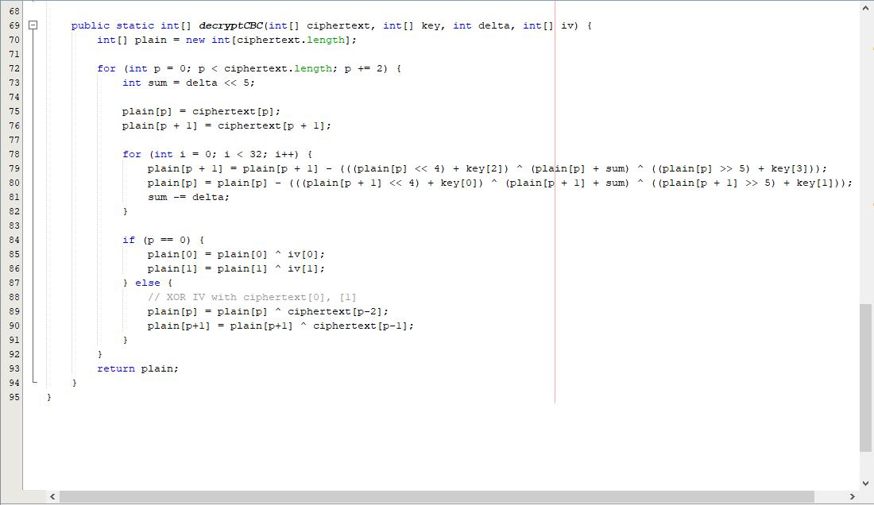

Test1 code is displayed below, and brings the inputs together, runs the processes and generates the output.
Again, it is critical to pay attention to the line numbers as displayed on the left side of the images to see how the code corresponds.
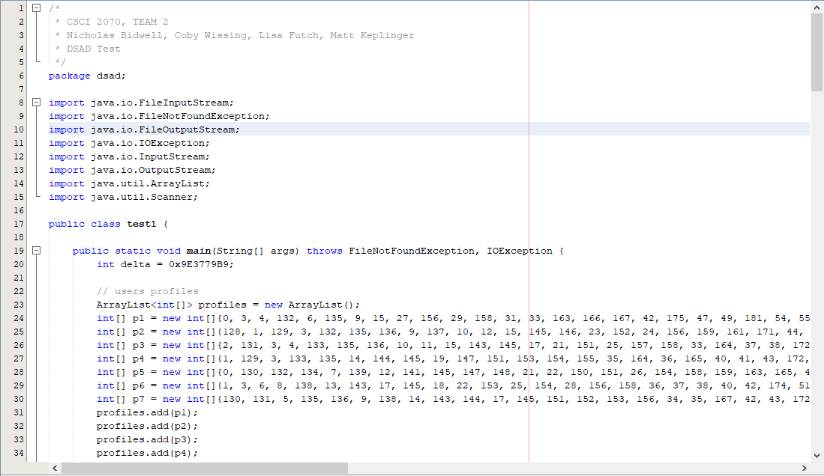
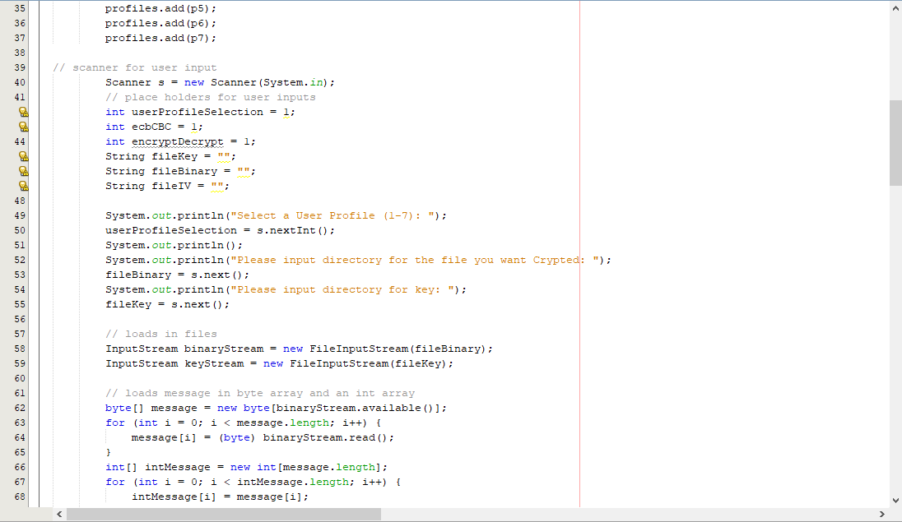
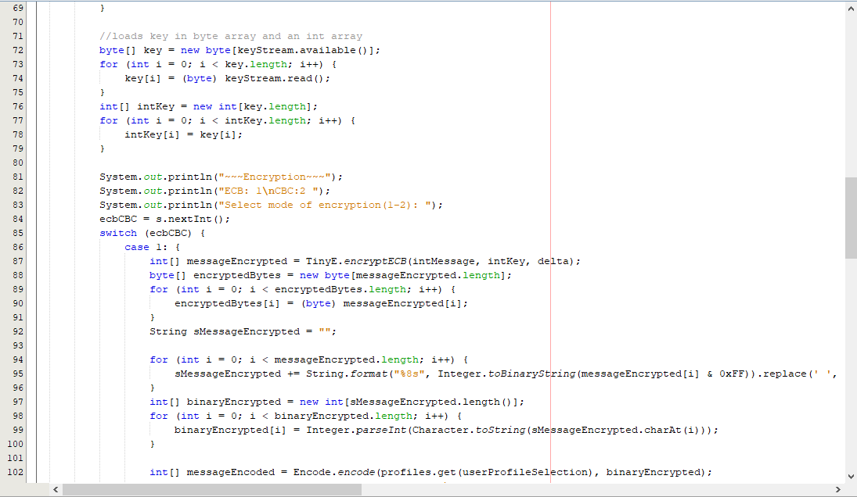
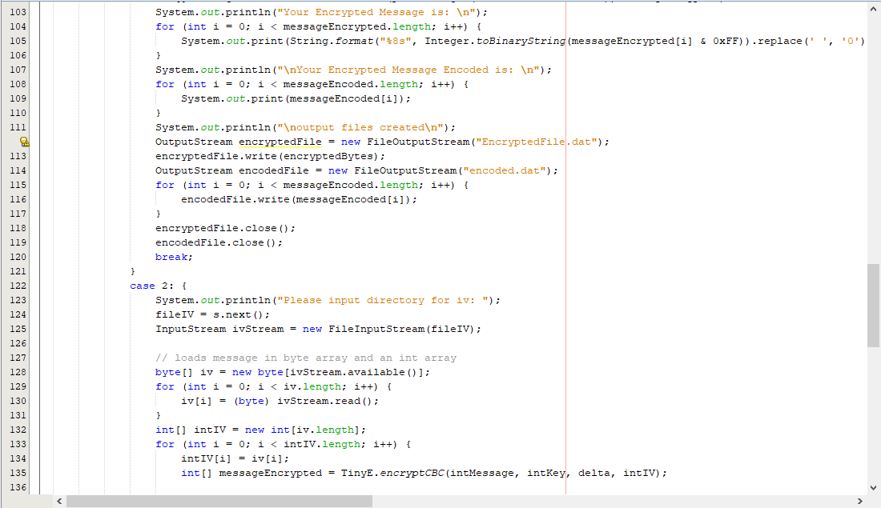
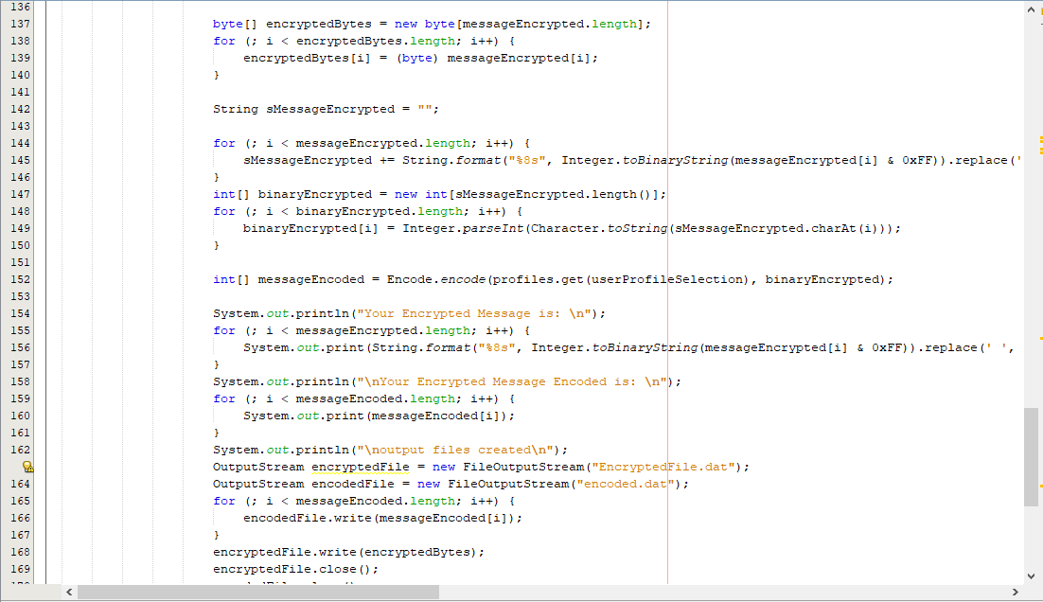
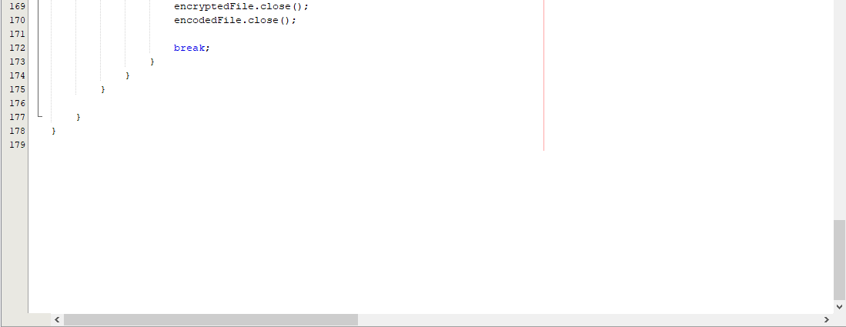

As a final executable, an image has been attached below to see the process and allow validation via the comparison of the initial message and decrypted message values. All appropriate files were already input, and the image shows an overview of the message and how it changes throughout the various processes, but retains message integrity at the end of the process, or “decrypted message.” Up to this point, code had been shown to allow reproduction of the various processes, but it is imperative that an end-user see what a proper procedure looks like for the application, as well as how to validate the message themselves.
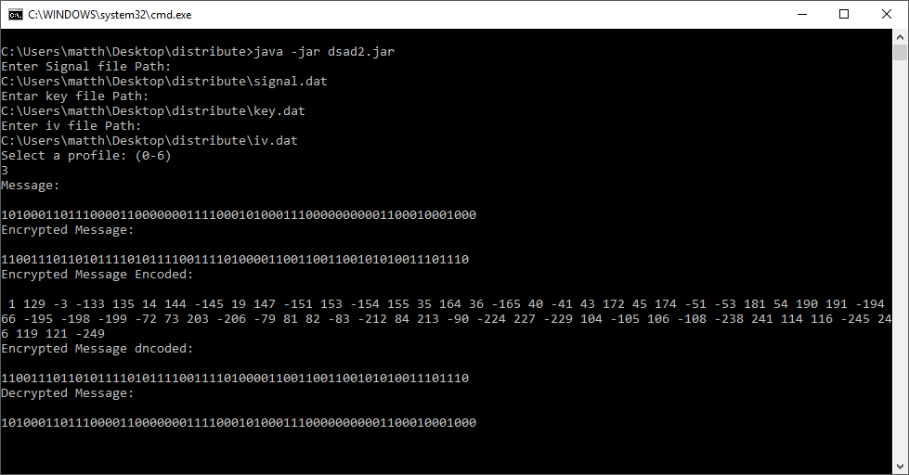

Experimental results
Upon initialization of the DSAD system, the user is asked to input a user profile, directories for the signal and key files, and choice of CBC or ECB. Displayed below is the result without exceptions being thrown for various issues with random profile generation and the use of the arrays to this point. The project was tested at various benchmarks to ensure that DSAD was going to run properly from initialization.
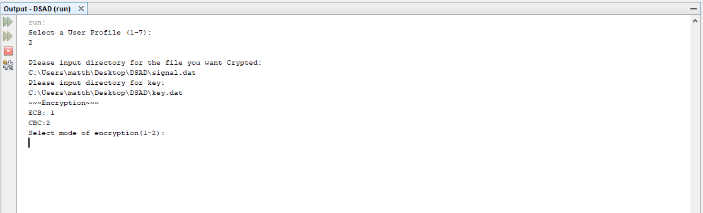
As displayed up to encryption mode, no issues arose with the directory designation, or the file generation of signal.dat or key.dat. When CBC is chosen, the console then requires the input for the iv.dat file as displayed.
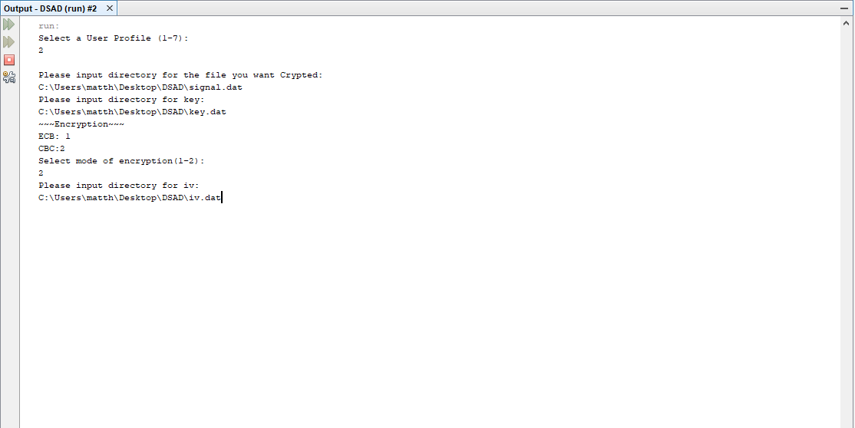
Initially, exceptions were thrown due to the array values, but this was fixed with code revisions to the arrays. The error was thrown because the value “0” was not a valid value for the array.
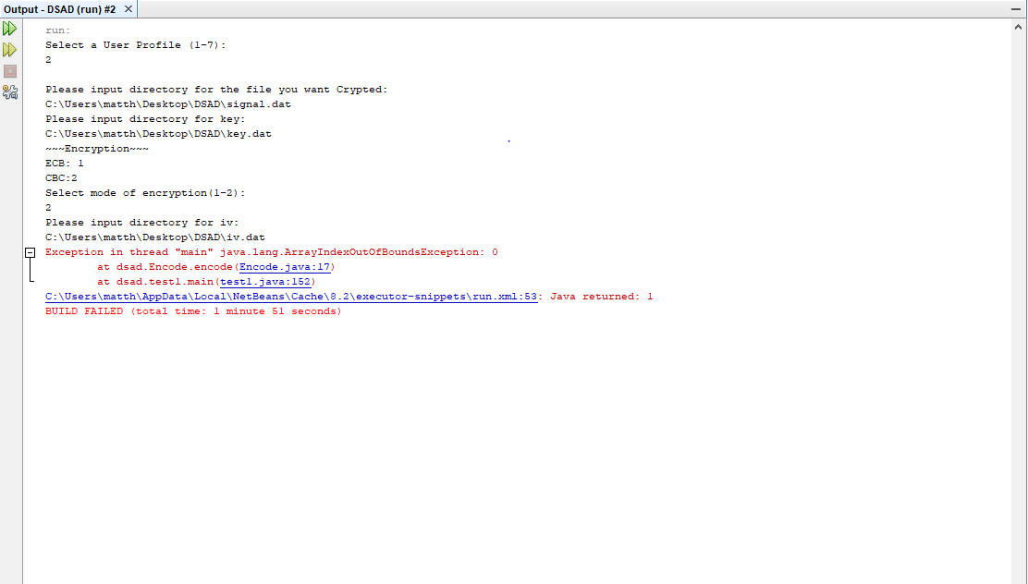
If ECB Mode is chosen, the IV.dat is not needed due to the operation of Electronic Code Book vs. Cipher Block Chaining. Below is a screenshot of a successful run of ECB with output generated with encryption, and with encoding. Initial programming generated an output file as indicated below, but that function was removed as it was deemed excessive.
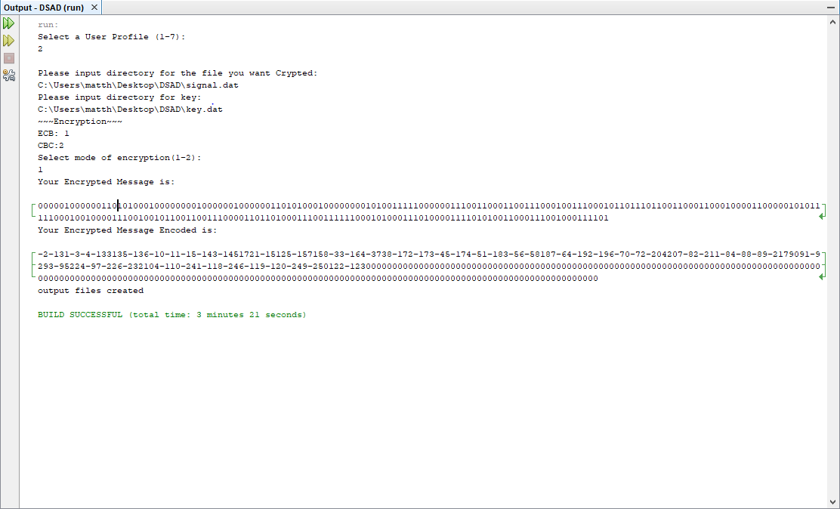

Code issues were fixed as they arose, and the files were compiled to an executable. A display of the executable is shown below with encryption, encryption with encoding, decoding, and decryption with decoding. Validation is completed by comparing the original message against the decrypted message values. Matching values indicate a successful encryption, encoding, decoding, and decryption process.

*****This Page Left Intentionally Blank. User Manuals Follow*****

User’s Manuals
User manual
Hardware Requirements:
Verify your system meets or exceeds the minimum hardware requirements:
- Java version 1.4.0 or greater
- 800MHz Intel Pentium III or equivalent
- 512MB Ram
- 750MB of free disk space
- Administrator privileges on your system
Download Eclipse Oxygen 64-bit.
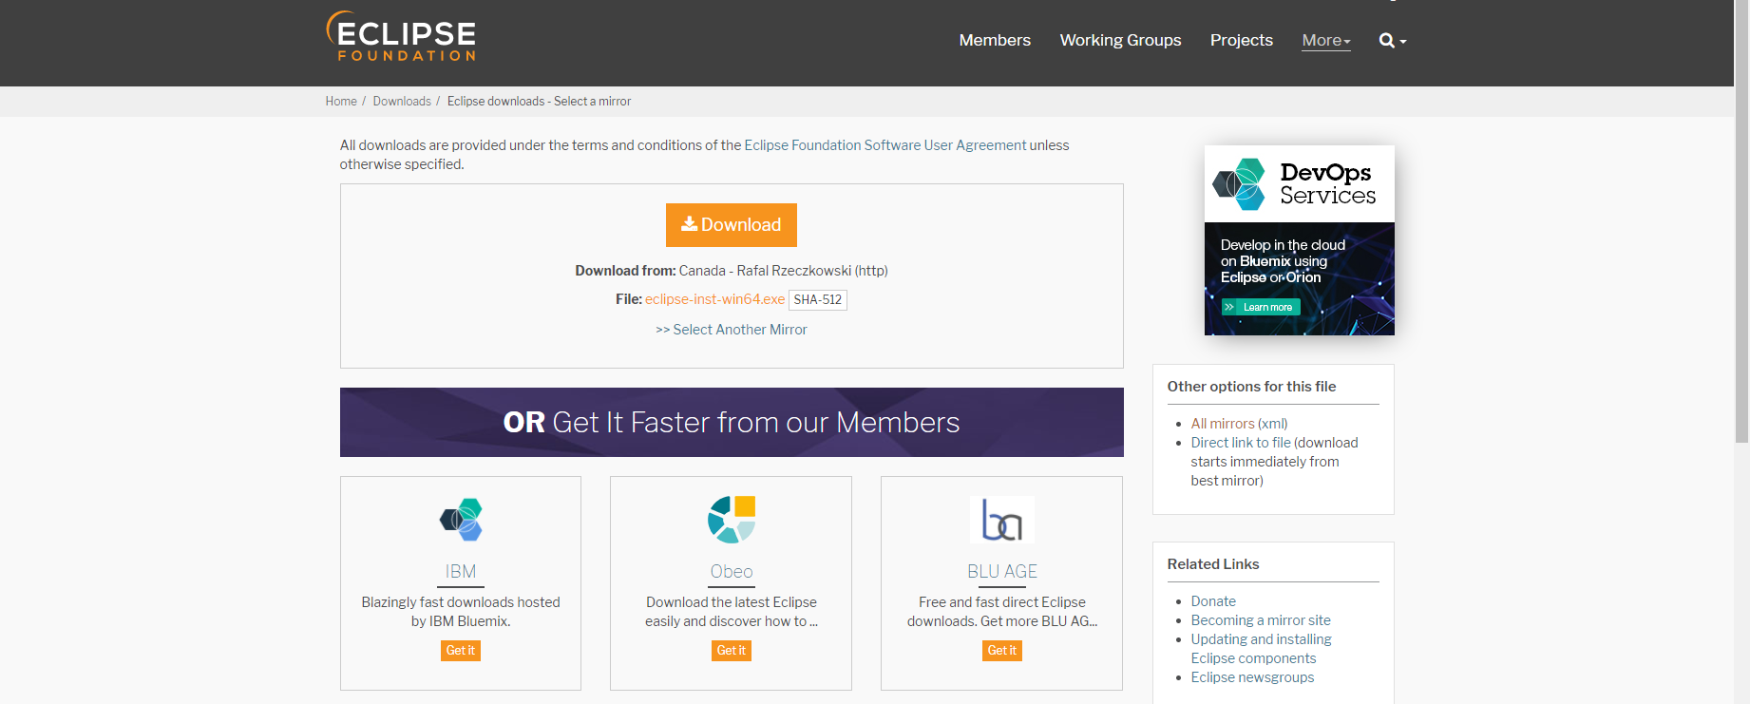
Run Eclipse Installer.
Select Eclipse IDE for Java Developers.
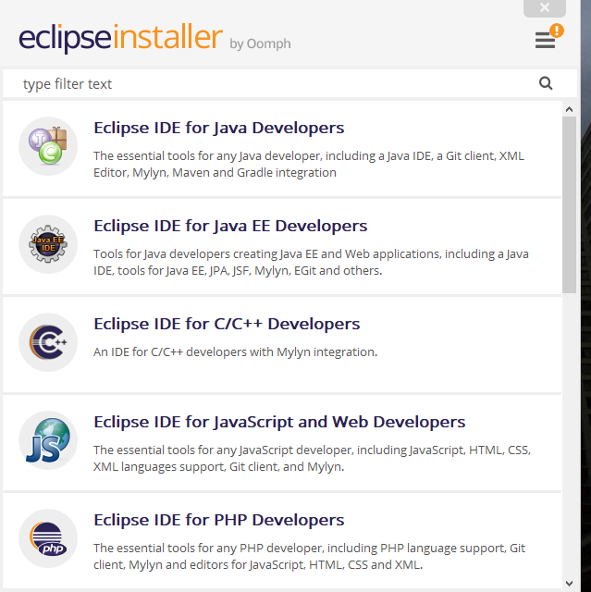
Click Install.
Once installed run Eclipse
From the main menu bar, select File > Import. The Import wizard opens.
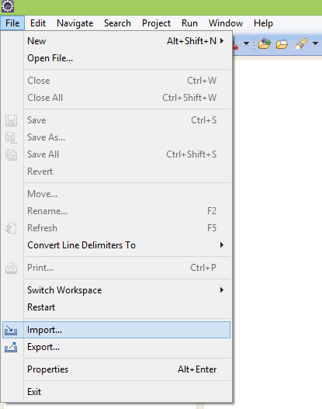
Collapse or click + in General > Existing Project into Workspace and click Next
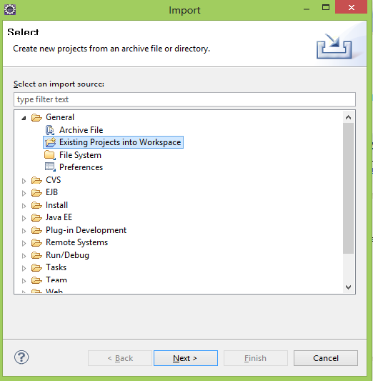
Under Projects select the project containing our files.
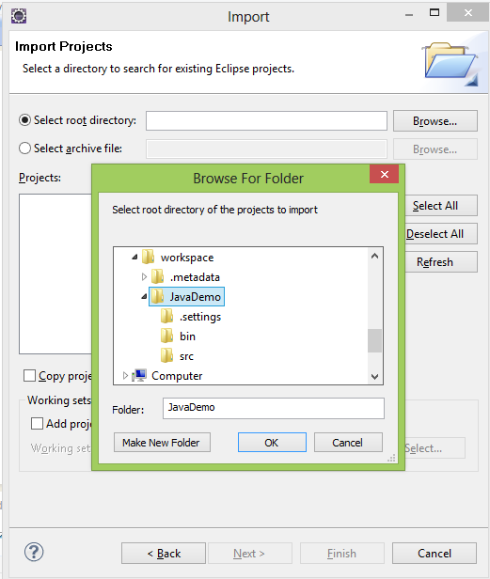
Click Finish to start the import
Click run to start the file
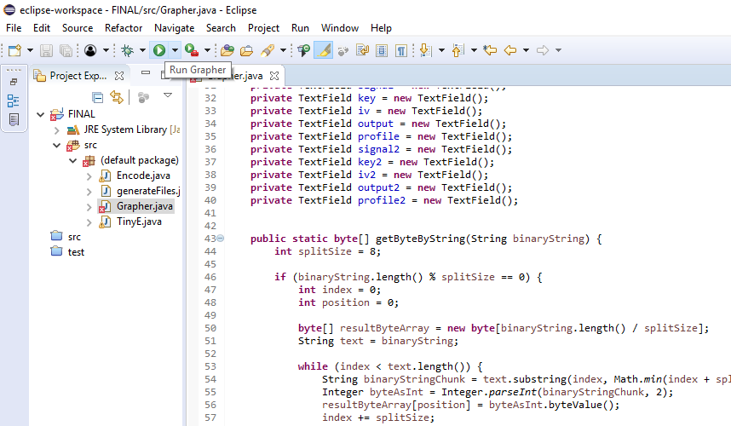
Enter the file names, and press encrypt to receive the output and graph
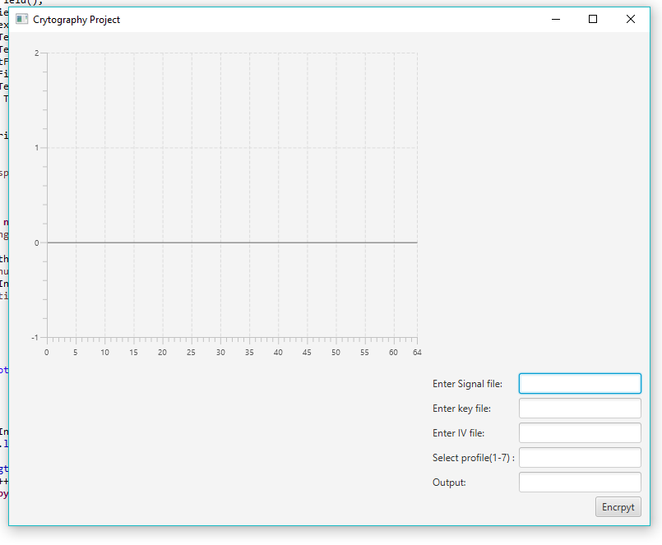
Enter the encrypted file names, and press decrypt to receive the output and graph.

CONSOLE VERSION OF APPLICATION INSTRUCTIONS (EXECUTABLE)
- Locate the directory of the DSAD.jar, for our purposes it will be in the “distribute” directory. Although dsad.jar is the java executable, to run on a windows machine the “run.bat” Windows batch file must be executed. It is highlighted below.
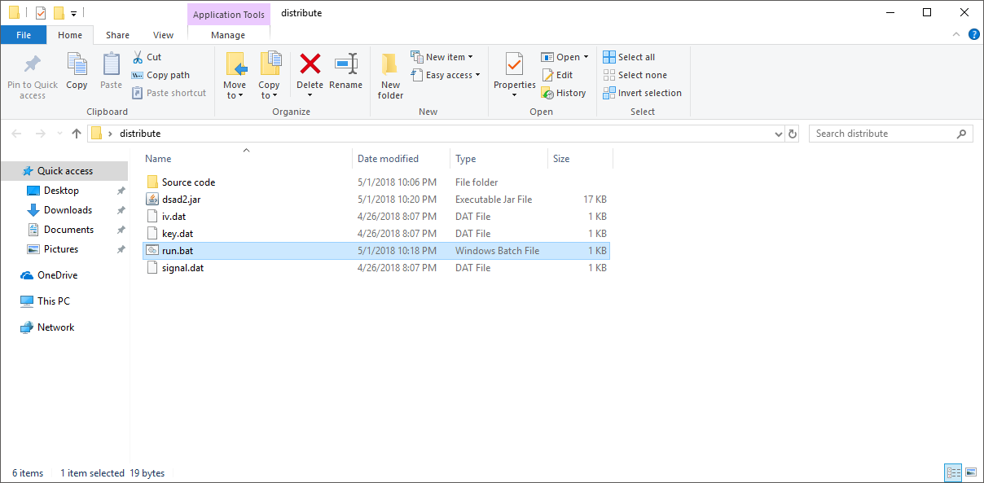

- Run the “run.bat” file by double-clicking it. The console will load and ask for the directories for the signal.bat, key.bat, and iv.bat files.
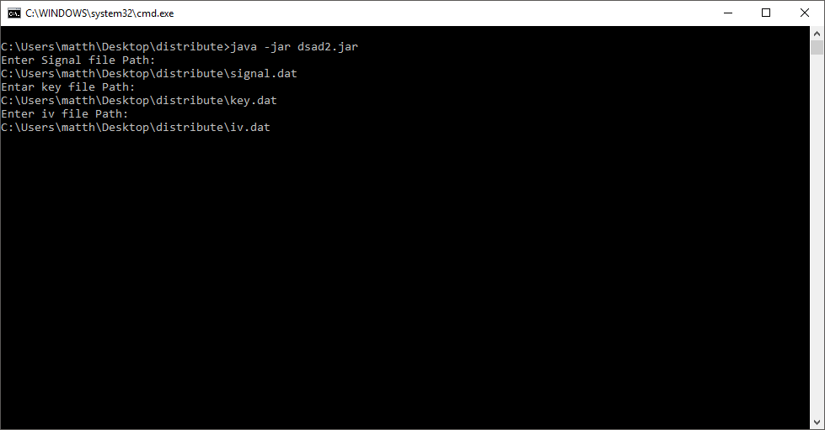
- Choose the user profile value and hit the enter key. The message will be displayed as it is encrypted, encoded, decoded, decrypted, and displayed.
Validation is completed upon the decrypted message output, and the message input being compared against each other.

